

Patient Panel
Specification

Version 02
03.19.2024

Table of Contents
Overview 3
1 Message Details 4
1.1 File Format 4
1.2 Panel Column Descriptions 4
1.3 File Details 4
2 Message Example 6
Revision History 7

Overview
This specification is for provider organizations to send patient panel files containing patient demographic information and Health Provider data to establish an active care relationship between an organization and their patients. FLHIE uses the patient panel to populate the patient’s care team, enable search for clinical information and populate FLHIE alerts.

Panel files will age-out after 90 days so a new panel will need to be submitted within 90 days from the last sent file. FLHIE will archive your panel files for 180 days. Hospitals typically share a 2-year historical feed of all patients who have had a visit in the past 2 years while provider practices typically share a list of active patients.

The same panel template is used, regardless if the panel is for ongoing patient encounters or historical patient encounters.

Message Details

File Format

The file must be:
‐ csv flat files;
‐ comma delimited formatted;

Naming Convention:
SourceCode-1-z-MM-dd-yyyy.csv
SourceCode is provided by CSS/FLHIE to each organization.

Panel Column Descriptions

- Please do not alter or delete any columns or headers
- If a column does not apply to you, please leave cells in that column blank
- All patient panels should be uploaded in .csv format.
- To do this, you may click “Save As” in Microsoft Excel, and choose the “CSV (Comma Delimited) (*.csv)” option ending in .csv
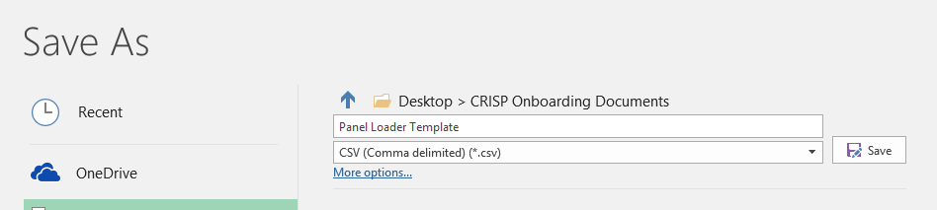
Columns that are filled out will be returned to the organization in notifications.
Ex. If you mark that a patient is in a Diabetes program, you will see that in the notifications.

File Details

Required Fields marked in Blue. Values in Green, provide if available. Values in Gray will appear on your alerts if you include them in the panel. Values in Orange, required on delta panels only. All other fields are optional.

COLUMN | CHARACTER LIMIT | EXAMPLE | 0DESCRIPTION
Group | 50 | Diabetes | You may choose to designate a group for a subset of your patients
Member_Status | 10 | ADD | Required for delta panels only. Acceptable values are ADD, UPDATE, or DELETE
Patient_ID | 50 | JD1234 | Practice-specific medical record number, usually from your EHR.
First_Name | 30 | John | Patient First Name
Middle_Name | 30 | M | Patient Middle Name
Last_Name | 75 | Doe | Patient Last Name
Name_Suffix | 10 | Jr | Patient Name suffix
Address_1 | 75 | 123 Main St | Number and Street Name
Address_2 | 75 | Apt. 1 | Additional address information
City | 50 | Columbia | City of patient's residence
State | 15 | MD | May be abbreviations or full name
Zip | 10 | 21044 | 5 digit zip code
Birthdate |  | 10/12/1978 | Must be in mm/dd/yyyy format
Gender | 10 | M | May be listed as letter or full (M or Male)
SSN | 15 | 123-45-6789 | If listed, must be full 9 digit SSN, dashes optional
Home_Phone | 15 | 301-555-9876 | If listed, must be full 10 digit phone number, dashes optional
Work_Phone | 15 |  | If listed, must be full 10 digit phone number, dashes optional
Cell_Phone | 15 |  | If listed, must be full 10 digit phone number, dashes optional
Practice | 50 | ABC Clinic | If an organization consists of multiple practices, you may specify here
Location | 50 | ABC Clinic - Easton | If an organization consists of multiple locations, you may specify here
PCP | 100 | Dr. Get-Better | Patient's PCP
NPI | 15 | 123456789 | Organization NPI
TaxID | 20 | 09-098765 | Organization Tax ID
Insurance | 50 | Medicaid | Patient Insurance
ACO | 100 | CareFirst | Patient ACO
Account_Number | 25 | Carefirst - 12345 | Patient account number, specific to a program or enrollment
CEND_Startdate |  | 11/31/2017 | Date that patient is first added to CEND roster. Must be in mm/dd/yyyy.
Care_Program | 100 | Diabetes | Care Program Name, if enrolled
Care_Program_StartDt |  | 10/10/2017 | Care Program start date. Must be in mm/dd/yyyy.
Care_Program_EndDt |  | 12/31/2017 | Care Program disenrollment date. Must be in mm/dd/yyyy.
Care_Manager | 100 | Sally Care | Care Manager Name
Care_Manager_Phone | 10 | 123-345-5678 | Care Manager Phone, must be 10 digit phone number
Care_Manager_Email | 20 | sallycare@care.com | Care Manager Email, must be in valid email format
RiskScore1 | 20 | Low | May enter a risk score. This will translate exactly like you type it.
RiskScore2 | 20 |  | Same as above
RiskMethodology1 | 100 | Fram. Risk Score | This would be used to name your 1st risk score
RiskMethodology2 | 100 |  | Same as above, name a 2nd risk score if you enter it
Region | 100 | ABC Clinic-X Region | If this patient is in a specific region that you serve, may enter it here
DirectEmail | 50 | Drx@crispdirect.org | If the patient's provider has a CRISP Direct email, may enter it here
DocHaloID | 50 | Provider ID | If the patient's provider has a DocHalo ID, you may enter it here
Follow Up Date |  | 01/15/2017 | Date follow up visit is scheduled. Must be in mm/dd/yyyy.
Appointment Missed Date |  | 01/16/2017 | Date appointment was missed. Must be in mm/dd/yyyy.
Care Alert
Assigning Authority Code

Message Example

CSS Patient Panel

Revision History

Date | Version | Author | Comments
1/28/2024 | 1.0 | FLHIE | Create initial document.
3/19/2024 | 2.0 | FLHIE | Added new fields to the panel: Race, Ethnicity, Specialist NPI, Specialist Name, Specialty

